

Adverbs

We can use adverbs to describe how somebody does something.

- True or false?
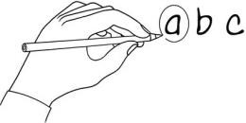
Read and circle true or false for these sentences.
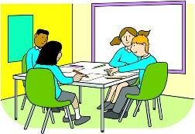
I like English. I work hard in class and I try to do my homework correctly. I always listen carefully to the teacher and I usually do well in tests. But I’m not very good at PE because I can’t run very fast and I play football terribly!

a. He likes English. | true | false
b. He tries to do his homework quickly. | true | false
c. He listens carefully to the teacher. | true | false
d. He usually does terribly in tests. | true | false
e. He runs fast. | true | false

Match them up!
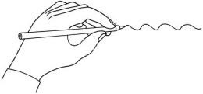
Match the adjectives and the adverbs.

bad beautifully

correct well

beautiful badly

terrible fast

good terribly

hard correctly

fast carefully

careful happily

happy hard
www.britishcouncil.org/learnenglishkids
© British Council, 2017 The United Kingdom’s international organisation for educational opportunities and cultural relations. We are registered in England as a charity.

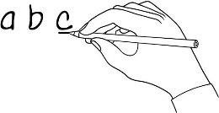
Make it right!
Find the mistake in each sentence and correct it.
- I play tennis bad. I play tennis badly.
- She doesn’t do her homework correct. She doesn’t do her homework correctly.

- He ran the race very fastly. He ran the race very fast.

- Do you speak English good? Do you speak English well?

- They didn’t work very hardly on the project. They didn’t work very hard on the project.

- My mum can sing beautiful. My mum can sing beautifully

- I ride my bike really carefuller. I ride my bike really carefully.

- We would happyly play on LearnEnglish Kids all day! We would happily play on LearnEnglish Kids all day!

Write and draw!

Draw a picture of your classroom and write about yourself like in exercise 1!

..........................................................................................................................................................................................................................................................................

..........................................................................................................................................................................................................................................................................

..........................................................................................................................................................................................................................................................................
www.britishcouncil.org/learnenglishkids
© British Council, 2017 The United Kingdom’s international organisation for educational opportunities and cultural relations. We are registered in England as a charity.

