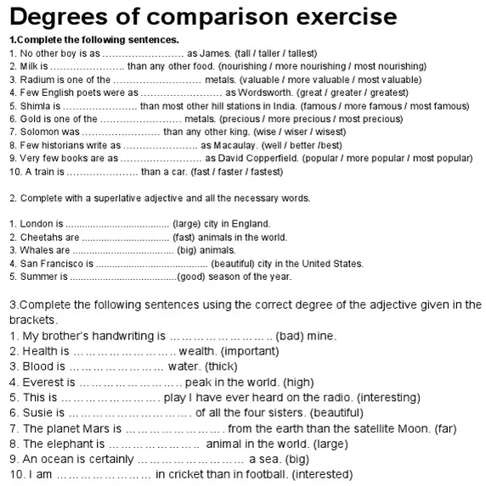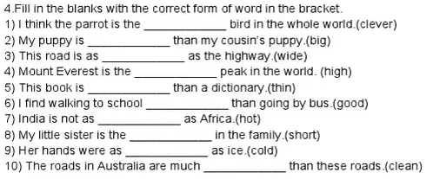

cleaner

cold



shortest

cleverest

hot

better

thinner

highest

wide

bigger

More interested

Bigger than

The largest

More far

The most beautiful

The most interesting

The highest

Thicker than

The most important

Worse than

faster

Popular

well

wiser

Most precious

More famous

great

Most valuable

More nourishing

tall

The best

The most beautiful

The biggest

The fastest

the largest